**Industrial Training Report**

On

**“Python Course”**

Submitted in

partial fulfilment of the degree of Bachelor of Technology

Rajasthan Technical University



By

Ishu Kumar

(PIET20CS080)

Department of computer engineering

Poornima Institute of Engineering and Technology

(Academic year 2019-2020)

CERTIFICATE BY COURSERA

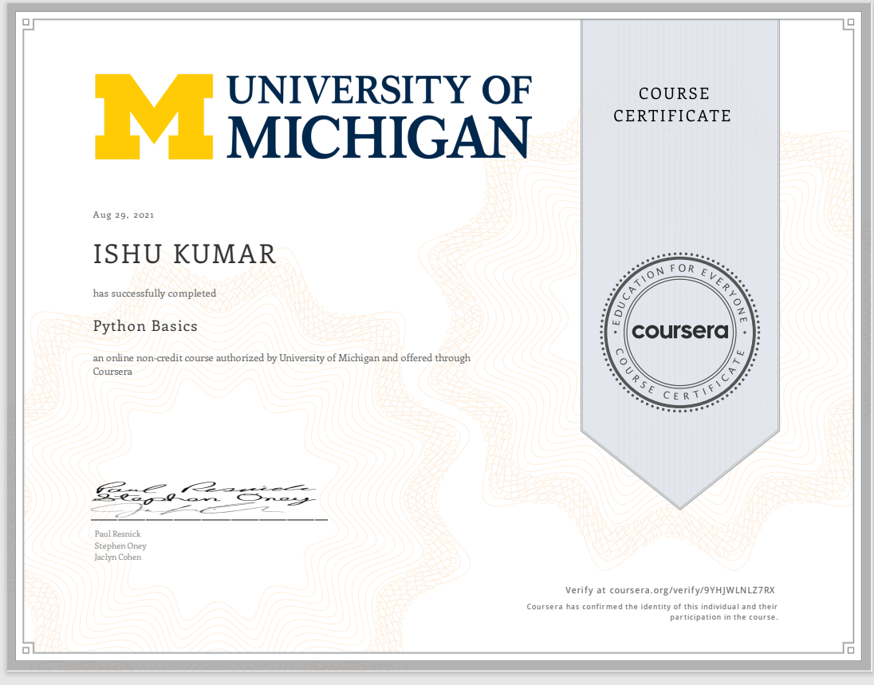

CANDIDATE DECLARATION

I “**Ishu Kumar**” hereby declare that I have undertaken **15 Days** industrial training at “**coursera**” during a period from 12th  AUGUST 2021 to 29th AUGUST 2021 in partial fulfilment of requirements for the award of degree of B.Tech (Computer Science & Engineering) at POORNIMA INSTITUTE OF ENGINEERING AND TECHNOLOGY, JAIPUR. The work which is being presented in the training report submitted to Department of Computer Science and Engineering at POORNIMA INSTITUTE OF ENGINEERING AND TECHNOLOGY, JAIPUR is an authentic record of training work.

It has not been submitted anywhere else for the award of any degree, diploma and fellowship of any University or Institution

Signature of the Student

**ACKNOWLEDGEMENT**

A project of such a vast coverage cannot be realized without help from numerous sources and people in the organization. I am thankful to **NANDANI SHARMA** and **PRIYANKA SHARMA** for providing me a platform to carry out such a training successfully.

I am also very grateful to **Mr. Deepak Moud (HOD,CE)** for his kind support.

I would like  to  take  this  opportunity to  show  my  gratitude  helped me in successful completion of my FIRST Year Practical Training. They have guided, motivated & were source of inspiration for me to carry out the necessary proceedings for the training to be completed successfully.

I would also like to express my hearts felt appreciation to all of my friends whose direct or indirect suggestions help me to develop this project [and to entire team members for their valuable suggestions.

Lastly, thanks to all faculty members of Computer Engineering department for their moral support and guidance.

**Company detail**

**Name of the company – COURSERA**

**Background of the company- COURSERA**

coursera, a is an American [massive open online course](https://en.wikipedia.org/wiki/Massive_open_online_course) provider founded in 2012, intends to do the same to the traditional instructional industry. Coursera has created a technological platform that allows novice instructors to plan, design, and produce video how-to instructions for almost any subject.

Its mission is to “help anybody learn anything online.” Its vision of the world is one in which everyone can teach and share what they know. As a publisher and promoter of video how-to instruction courses targets to several different, though related, markets: The instructor who creates the course, the student who takes the course, and organizations that might utilize Coursera technology to create specialized courses as a branded product or for internal employee use.

**ABSTRACT**

Industrial training is an important phase of a student life. A well planned, properly executed and evaluated industrial training helps a lot in developing a professional attitude. It develops an awareness of industrial approach to problem solving based on a broad understanding of process and mode of operation of organisation. The aim and motivation of this industrial training is to receive discipline, skills, teamwork and technical knowledge through a proper training environment, which will help me, as a student in the field of information technology, to develop a response of the self-disciplinary nature of problems in information and communication technology. During a period of one month training at courser, coursera and throughout this industrial training. i have been learned new programming language that require for the system web programming is a basic subject in computer and informatics engineering, a program study in a vocational high school it require logical thinking ability in the learning activities. The purpose of this research were (1)to develop a web programming module that implement scientific approach that can improve logical thinking ability for students in vocational high school and,(2) to test the effectiveness of web programming module based on scientific approach to train students logical thinking ability the result of this research were a web programming module that applies scientific approach for learning activities to improve logical thinking ability of students in the vocational high school. The results of the effectiveness test of web-programming module give conclusion that iit was very effective to train logical thinking ability and to improve learning result.

**TABLE OF CONTENTS**

**Course 1- Python**

**CHAPTER-1 INTRODUCTION 11-17:**

**1.1 welcome to python basic**

[**1.2** **introduction**](https://docs.google.com/document/d/1zixX3EzDU8S0pHfamBLcEvCL0fYmuJqdrUT9DUsBysY/edit#heading=h.26in1rg)

**1.3 basic of programming**

**1.4. the way of programmer**

**1.5. quiz**

**1.6. assignment**

**CHAPTER 2 STRING, LISTA, TUPLES 17-24**

**2.1** **String**

**2.2** **iteration**

**2.3** **way of the programmer**

**2.4. quiz**

**2.5. assiment**

**CHAPTER-3 BOLLEAN 24-28**

**CHAPTER-4 USING LISTS IN GENERAL 29**

LIST OF FIGURES

Figure no caption page no

Fig.1. Features of python 11

Fig.2 Application of python 12

LIST OF TABLES

Table no. Title of table Page

* 1. Keywords 10
  2. logical operator 14
  3. Assignment

**Chapter-1**

**INTRODUCTION**

* 1. WELCOME TO PYYHON

We are welcome to you to start the cource

**1.2.INTRODUCTION**

Python is a general-purpose, high-level programming language which is widely used in the current times. It emphasizes code readability, and its syntax allows programmers to express concepts in fewer lines of code than other languages such as C. It helps the user to write clear programs on both a small and large scale. The most important feature of this language is that it supports multiple programming paradigms, including object- oriented, imperative and functional programming or procedural styles. It supports a dynamic type system and automatic memory management and has a large and comprehensive standard library. Python interpreters are available for many operating systems

**Python Features:**

There are lot of features provided by python programming languages

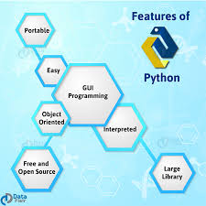

Figure 1: Feature of Python

1) Python is easy to use and high level language. Thus it is programmer-friendly language.

2) It is more expressive. The sense of expressive is the code is easily understandable.

3) Python can equally on different platforms such as Windows, Linux, Unix, Macintosh etc.

4) It is freely available (www.python.org). The source-code is also available. Therefore, it is

open source.

5) Python has a large and broad library.

6) Graphical user interfaces can be developed using python.

7) It can be easily integrated with languages like C, C++, JAVA etc.

Application of python-

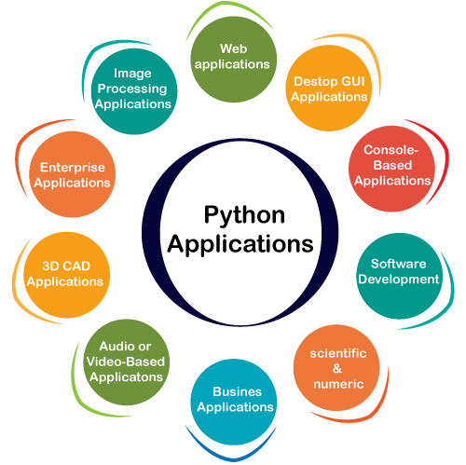Python as a whole can be used in any sphere of development. The major regions where python proves to be handy.

Figure 2: Application of python

**Console Based Applications:**

Python can be used to develop console based applications. For example: I Python

**3D CAD Applications:**

Fandango is a real application which provides full features of CAD

**Audio or video based Applications:**

Python proves handy in multimedia section. Some of real applications are: TimPlayer, cplay etc.

**Web Applications:**

Python can also be used to develop web based application. Some important developments are:

Python Wiki Engines, Pocoo, Python Blog Software etc.

**Enterprise Applications:**

Python can be used to create applications which can be used within an Enterprise or an

organisation. Some real time applications are: OpenErp, Tryton, Picalo.

. **Tokens of Python**

Tokens can be defined as a punctuator mark, reserved words and each individual word in a statement. Token is the smallest unit inside the given program.

There are following tokens in Python:

1) Keywords

2) Identifiers

3) Literals

 4) Operators

**Keywords or Reverse Words**

    Keywords are special reversed words which convey a special meaning to the compiler/interpreter. Each keyword has a special meaning and a special meaning and a specific operation. List of Keywords used in Python are:

|  |  |  |  |  |
| --- | --- | --- | --- | --- |
| True | False | None | And | As |
| Asset | Def | Class | Continue | Break |
| Else | Finally | Elif | Del | Except |
| Global | For | If | From | Import |
| Nonlocal | In | Rot | Is | Lambda |
| Raise | Try | Or | Return | Paas |
|  |  |  |  |  |

Table1.1.keywords

**. Operators**

1. Arithmetic Operators

2. Relational Operators

3. Assignment Operators

4. Logical Operators

5. Identity Operators

6. Bitwise Operators

1)Arithmetic Operators:

|  |  |
| --- | --- |
| // | Integer Division |
| + | To Perform Addition |
| _ | To Perform Subtraction |
| * | To Perform Multiplication |
| / | To Perform Division |
| % | To return remainder after division |
| ** | Perform exponent (raise to power) |

Table.1.2.arithmetic operators

2)Relational Operators:

|  |  |
| --- | --- |
| < | Less than |
| > | Greater than |
| <= | Less than or equal to |
| >= | Greater than equal to |
| == | Equal to |
| != | Not equal to |
| <> | Not equal to (similar to !=) |

Table1.3.relationals operators

3)Assignment Operators:

|  |  |
| --- | --- |
| = | Assignment |
| /= | Divide and Assign |
| += | Add and assign |
| -= | Subtract and assign |
| *= | Multiply and assign |
| %= | Modulus and assign |
| **= | Exponent and assign |
| //= | Floor division and assign |

Table 1.3. assignment operators

4)Logical Operators:

|  |  |
| --- | --- |
| And | Logical AND (When both conditions are true and output will be true. |
| Or | Logical OR (if any one condition is true output will be true) |
| Not | Not Logical NOT (Compliment the condition i.e., reverse) |

Table1.4.logical operators

5)identity Operators:

|  |  |
| --- | --- |
| Is | Returns true if identity if of two operands are same, else false |
| Is not | Returns true if identity of two operands are not same, else false |

                                      Table 1.5. identity operators

6)Bitwise operator

|  |  |  |
| --- | --- | --- |
| Operator | Meaning | Example |
| & | Bitwise AND | x & y = 0 (0000 0000) |
| | | Bitwise OR | x | y = 14 (0000 1110) |
| ~ | Bitwise NOT | ~x = -11 (1111 0101) |
| ^ | Bitwise XOR | x ^ y = 14 (0000 1110) |
| >> | Bitwise right shift | x >> 2 = 2 (0000 0010) |
| << | Bitwise left shift | x << 2 = 40 (0010 1000) |

Table1.6.bitwise operator

**Identifiers:**

  Identifiers are the names given to the fundamental building blocks in a program. These can    be variables, class, object, functions, lists dictionaries etc.

There are certain rules for naming i.e. Identifiers.

 An identifier is a long sequence of characters and numbers.

 No special character except underscore (_) can be used as identifier.

 Keyword should not be used as an identifier name.

 Python is case sensitive. So using case is significant.  First character of an identifier can be character, underscore but not digit.

**Selective Statements**

The if statement in python is same as c language which is used test a condition. If condition is

true, statement of if block is executed otherwise it is skipped.

**Simple if**

if (condition):

statements

**if with else**

if (conditions):

statements

else:

statements

**Ladder if**

if statement:

body

elif statements:

body

else:

body

**Nested if**

if statement:

if statement:

body

else:

body

else:

body

**1.5 QUIZ**

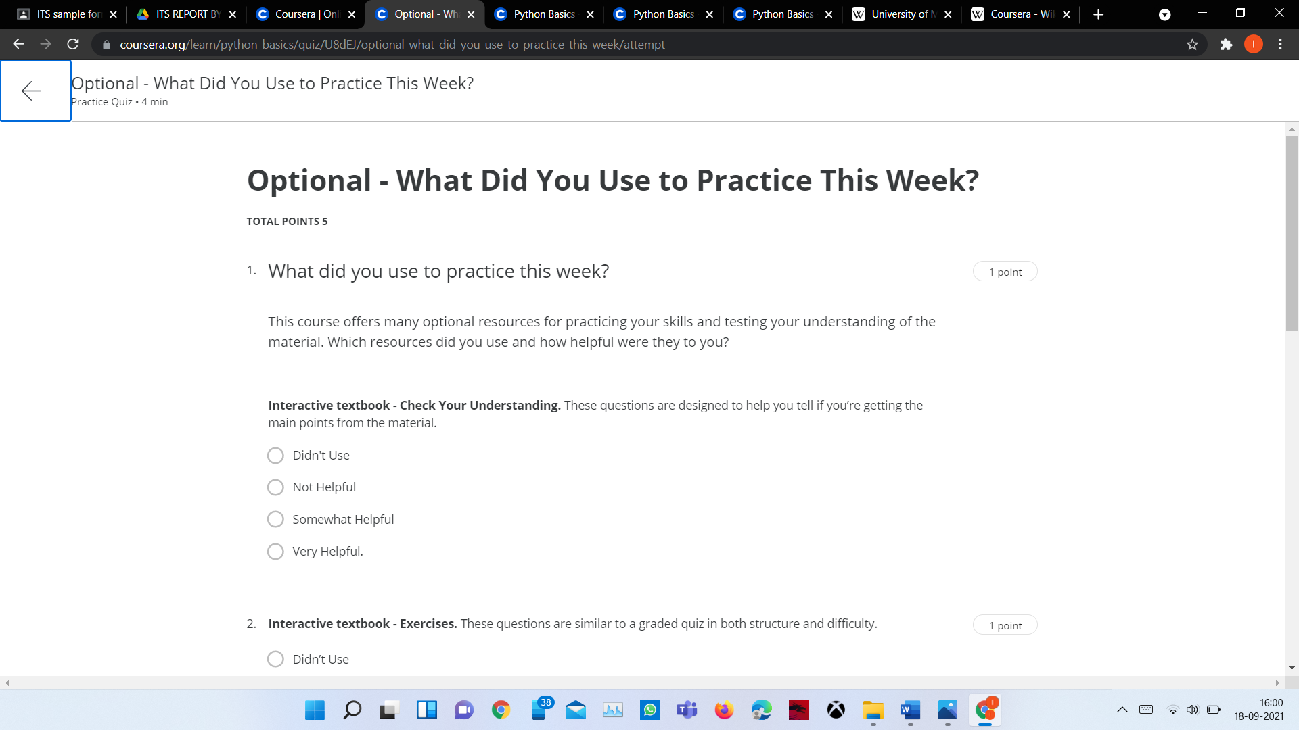

**Chapter 2**

**STRING**

**2.STRINGS:**

a string is a sequence of characters.

Strings can be created by enclosing characters inside a single quote or double-quotes. Even triple quotes can be used in Python but generally used to represent multiline strings and docstrings.

# defining strings in Python

# all of the following are equivalent

my_string = 'Hello'

print(my_string)

my_string = "Hello"

print(my_string)

my_string = '''Hello'''

print(my_string)

# triple quotes string can extend multiple lines

my_string = """Hello, welcome to

the world of Python"""

print(my_string)

When you run the program, the output will be:

Hello

Hello

Hello

Hello, welcome to the world of Python

#### 1)String concatenation:

#### Python strings can be concatenated with a + sign. For those, who do not know what concatenation is, it joins (or links or places side by side) two or more strings together. So, concatenation of words Hello and World will provide is a new string object - HelloWorld. Lets check this in the

index-

**2.2 LIST:**

 A List is a collection which is ordered and changeable. In Python lists are written with square brackets. Python list are the data structures that is capable of holding different types of data .

 Python lists are mutable that is python will not create a new a list is we modify an element in    the list.

A list can be composed by storing a sequence of different type of value separated by Commas

A Python list is enclosed between square brackets

 The element is stored in the index basis with starting index as zero.

**List Methods**

Python has a set of built-in methods that you can use on lists.

Method Description append()Adds an element at the end of the listclear()Removes all the elements from the listcopy()Returns a copy of the listcount()Returns the number of elements with the specified value extend()Add the elements of a list (or any iterable), to the end of the current listindex()Returns the index of the first element with the specified valueinsert()Adds an element at the specified positionpop()Removes the element at the specified positionremove() Removes the item with the specified valuereverse()Reverses the order of the listsort()Sorts the list.

**2.3.TUPLE**

 A tuple is a sequence of immutable objects, therefore tuple cannot be changed.

The objects are enclosed with parenthesis and separated by comma.

Tuple is similar to list. Only the difference is that list is enclosed within square bracket,

tuple within parenthesis and list have mutual objects whereas tuple have immutable

objects.

**Advantages:**

Processing of tuples are faster than lists.

 It makes the data safe as Tuple are immutable and hence cannot be changed.

 Tuple are used for String formatting

A tuple is a collection which is ordered and unchangeable. In Python tuples are written with round brackets.

**QUIZ**

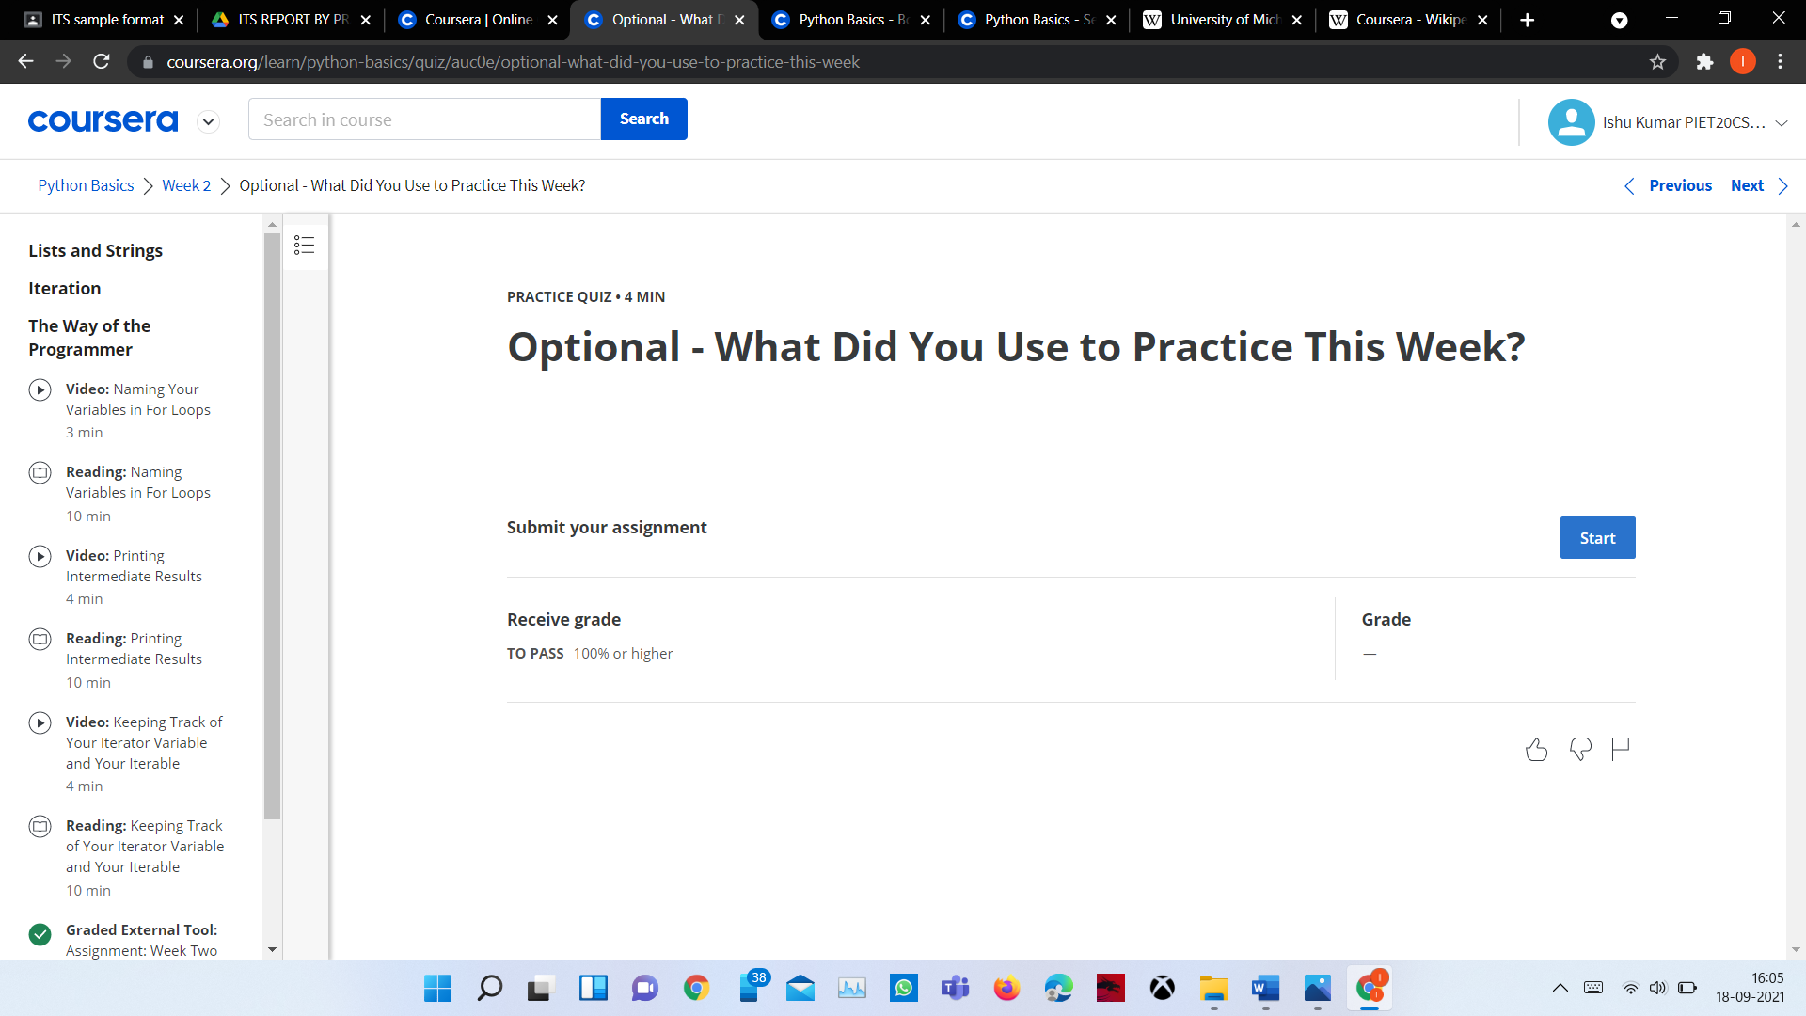

**CHAPTER-3**

**BOLLEN**

**3.1 bollen**

The python data type **bool** is used to store two values i.e True and False.

Bool is used to test whether the result of an expression is true or false.

## Syntax

To check the boolean value of an expression or a variable, pass it as a parameter to the bool function:

print(bool(expression))

or

print(expression)

## Where to use bool?

Bool can be used when there is a need to compare two or more values.

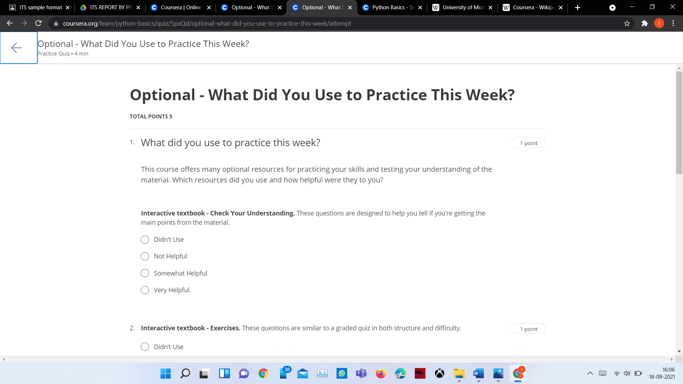

>>>

**CHAPTER-4**

**GENERAL**

**Future Scope of Python in India**–

Python is one of the most prevalent coding languages of 2015. Alongside with being a high-level and general-purpose programming language, **Python** is also an object-oriented and open source. At the similar time, a worthy number of developers crosswise the world has been making use of Python to create **GUI applications, websites, and mobile apps.**

The programming language is presently being used by a number of high-traffic websites including **Google, Yahoo Groups, Yahoo Maps, Shopzilla and Web Therapy**. Similarly, Python also discovers a countless use for creating gaming, financial, scientific and instructive applications.

**MY PROJECT IS : -**

* Web browser .
* In which I have named my browser a DORAEMON.

**IMPORTANTS MARKS : -**

* PROJECT TYTLE DORAEMON.
* PROJECT OBJECTIVE To make a fast or safe browser in which

We focused on privacy .

* PROJECT TECHNOLOGY It is based on python.

**PROJECT OUTCOME: -**

* The main purpose of making this projects is to making it fast and secure search engine.
* It is application software for accessing . When we follows the  from a particula r website .
* Web browsers are used on a range of devices, including , but my project is fully desktop mode.

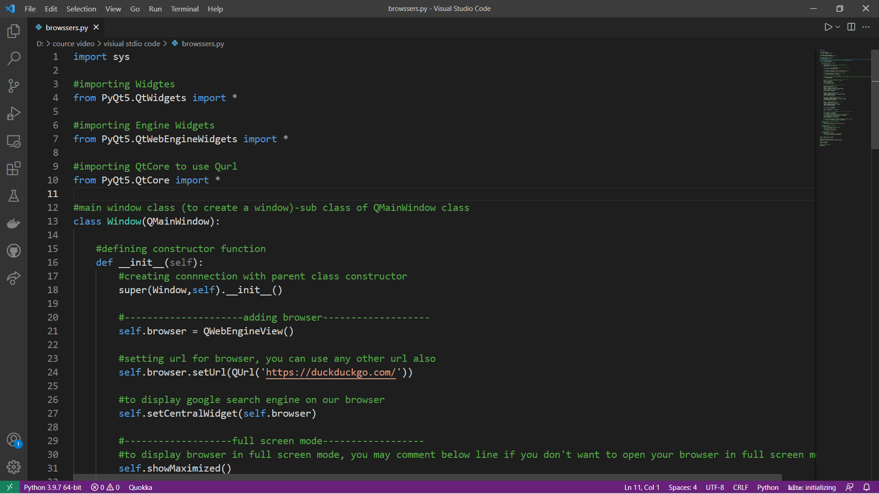

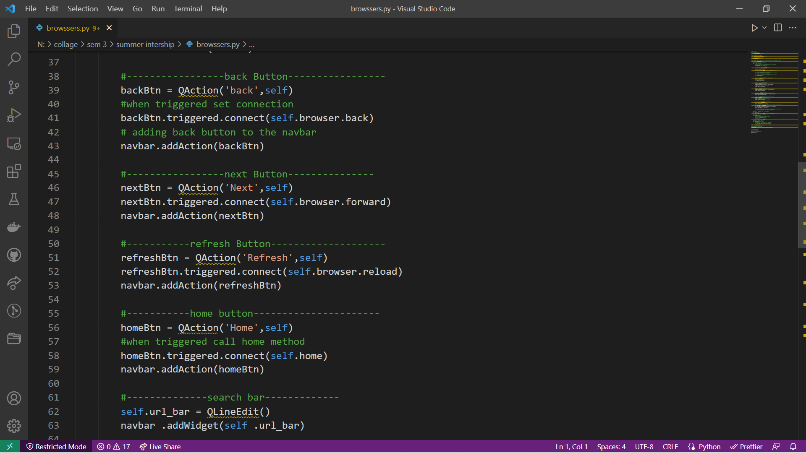

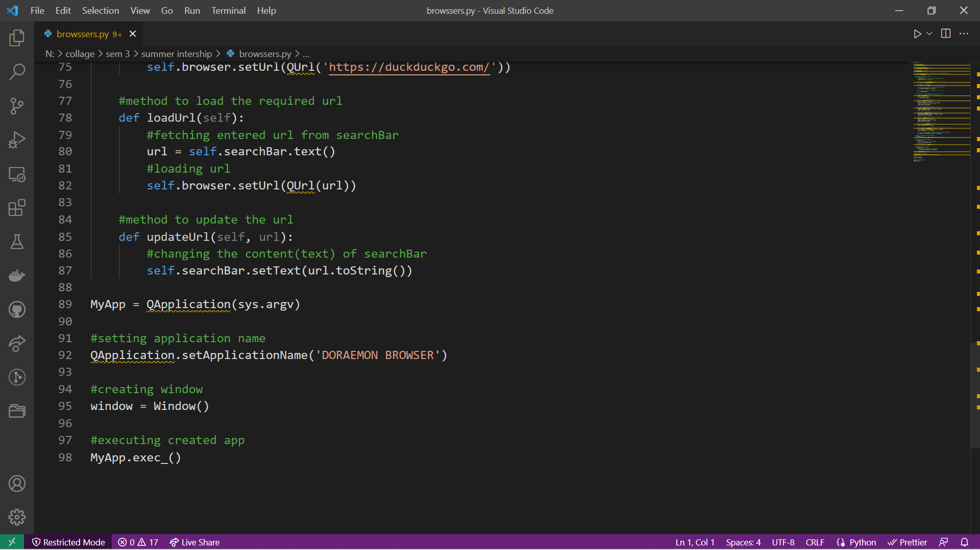

**Output:-**

